BASIC POWER SYSTEMS

V = Volts = E
KVA = Kilo Voltamperes, apparent power as measured by product of (V) (A)
KW = Kilowatts, real consumed power

KVAR = Kilo Voltamps reactive, imaginary power

I = A= Amperes current flow

θ= Angle of power triangle Cos θ = P. F.
Cos θ= P.F. = power factor = Watts = KW
Volts x Amperes KVA

BASIC POWER EQUATIONS
KW = (Volts) (Amperes) (P. F.) /1000 for 1∅ = (KV) (Amperes) (PF)
KW =(Volts)(Amperes)(P.F.) (√3) /1000 for 3 ∅ = (KV) (Amperes) (PF) (√3)
KVA = (Volts) (Amperes) / 1000 For 1∅ = (KV) (Amperes) (PF)
KVA = (Volts) (Amperes)( √3) /1000 for 3∅ = (KV) (Amperes)(√(3)
I = Current Per Phase (Amperes) (A)

I = KVA For 1 ∅, I = KVA For 3∅
KV KV √3

Normally, either KVA or current (I) amperes is given for loads to describe how much power is consumed.

Power factor = 1 for resistive loads such as Resistance Heaters, incandescant lights, stoves or other non-motorized equipment.

Power factor <1 for all other inductive loads such as motors, transformers, reactors and capacitors.

KVAR = (KVA)(Sinθ)

To properly add loads together,; they must be added vectorially, that is KW (Kilowatts from each load must be added together and KVAR's must be added together to get the resultant KVA which is used to find total power comsumption, or to calculate total line current for use in sizing wire or circuit breakers.

Example
Find total KVA, P.F., KVAR, line current (Per ^{p}hase) for the following loads:

Given
Voltage: 240V, 3 ∅

Loads: All 240V 3 ∅
1-5HP motor 3 ∅ 5.7KVA, 4.8KW from table on starting KVA
1-10HP motor 3 ∅ 10.3 KVA, 8.7KW from table on starting KVA

Unit Heater 1OKW 3 ∅ Resistive

Misc. Loads 5KW 3 ∅ Resistive.

Solution:
5HP motor 5.7KVA, 4.8KW
PF = 4.8KW = .8421 = Cos θ, θ = 32.636⁰
5.7KVA

Sin θ= .5393 KVAR = KVA(Sine θ) (5.7KVA) (.5393)

KVAR = 3.07, I = 5.7KVA
Phase .24 KV √3 13.7 Amps per phase

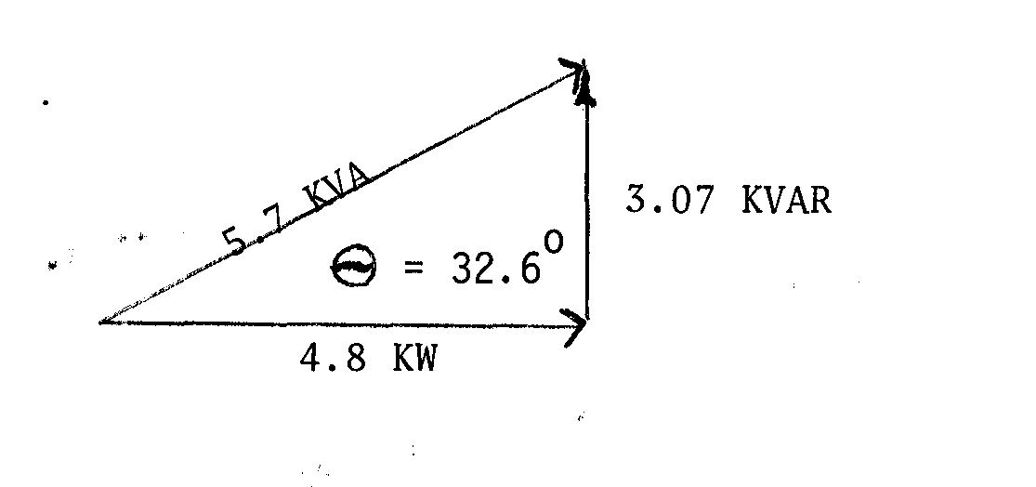

1OHP Motor 10.3 KVA, 8.7KW
P.F. = 8.7KW = .844 = Cos θ, θ= 32.36°
Sin θ =.535
KVAR = KVA (Sin θ) = 10.3KVA (.535) = 5.5136KVA

^{I} phase 10.3KVA = 24.77 A
.24KV √3

Unit Heater 10KW 10KVA

P. F. = l 0KW = 1 = Cos θ, θ = 0°
10KVA

Sin θ = 0 KVAR = (Sin θ) = ( 10KVA) (0) = 0

10 KVA
10KW KVAR = 0 θ= 0°

I phase = 10KVA
.24KV √3 = 24.05 A 10KVA } KVAR= 0, θ= 0°
10KW
. Misc. Loads

5KVA, 5KW

P.F. = 5KW = 1 = Cos θ, θ =0° Sin θ = 0
5KVA

KVAR = KVA (Sin θ) = 5KVA (0) = 0

5KVA
5K W 3 KVAR = 0 θ =0

I Phase = 5KVA
.24KVA √3 = 12.02 A
SUMMARY
LOAD KW KVAR KVA

5HP Motor 4.8 3.07 5. 7
10HP Motor 8.7 5.51 10.3
Unit Heater 1OKW 10 0 10
Mic. Loads 5KW 5 0 5

28.5 KW 8.58 KVAR 31KVA*

*Note do not add KVA algebraically, they are out of phase and will give you the wrong answer.

KVA = √(KW)2 + (KVAR)2
= √(28.5)^2 + (8.58)^2
= √812 + 73.61
√885.86 = 29.7KVA

P.F. = 28.5KW = .959 = Cos θ, θ= 16.75°
29.7KVA
Total KVA = 29.7, KVAR = 8.58, KW = 28.5, P.F. = .959

I = 29.7KVA = 71.44 A/ phase total
. 24KV √3
Approximate Method: (not breaking KW and KVAR into components and adding.)
Useable if load is mostly resistive *

Load KVA KW
5HP Motor 5.7 4.8
IOHP Motor 10.3 8.7
Unit Heater 10.0 10.0
Misc. Loads 5 5

*31KVA 28.5
Not Correct

31KVA approximate 29.7KVA actual.

Approx. P .F. = 28.5KW = .919
31 KVA

Actual P. F. = 28.5KW = .959
29.7KVA
Iapprox. = 31KVA = 74.57 A Approx.
.24KV √3

Iactual = 29.7 KVA
.24KV√3 = 71.4 A actual
4.1% error or 3.17 A

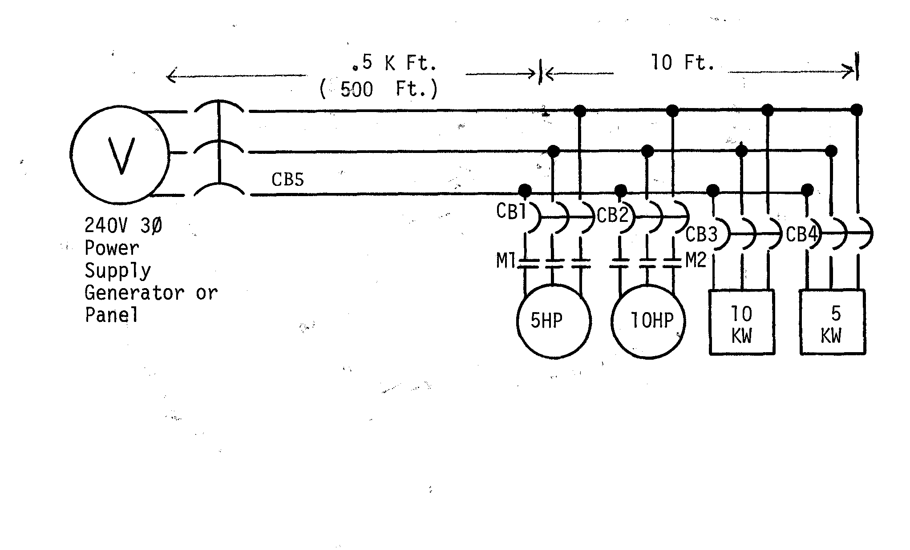

Problem
Size wire, motor starter, circuit breaker for each load, feeder wire and breaker size.

5HP motor KVA=5.7, KW = 4.8, I = 13.7A

10HP motor KVA=10.3, KW = 8.7, I = 24.77A

IOKW Heater KVA=10, KW = 10, I = 24.05A

5KW Misc. KVA=5, KW = 5 I = 12.02A

5HP Motor 240V, 3∅

Starter MI/Size 1 Furnas 14-81 Page 3. Max. 7.5 HP

I =13.7A derate wire 80%

I =13.7A = 17.1 A USE #12 copper which carries 20A next standard wire
.8 size larger Table 310-16 NEC. THW INSULATION 75°C.
Overload heater Furnas Page 82, Size 1 melting alloy, standard trip, go to table 29H for heater size,
F.L.A. = 13.7 Select H-36 range 12.3-13.8A

5HP Motor

Circuit Breaker Size

Table 430-152. Inverse time breaker. No starting code letter or Code F to V maximum size 250% of full load amps up to next standard size of breaker. I usually use 200% for motor starting.

I = 13.7A for 5HP motor.

Circuit Breaker = 2.0(13.7A) = 27.4
CB1 Use 30A breaker maximum which is next standard size higher if motor will start with smaller breaker, it should be used.

MCP magnetic circuit protector breaker Recommended for best protection of motor loads.

Size 1.25(13.7A) = 17.1A

USE MCP rated for 30A continuous. Westinghouse Page 203.

10HP Motor

I = 24.77A Starter M2 Size 2, page 14-Bl. Furnas thermal overload selection Page 82, Size 2, Standard trip melting alloy,
go to table 26073 to find heater size. Select H⁻42 heater element, 24.2⁻27.1 amps.

Wire Size 24.77A = 30.96 USE #8 Cu. THW, #8Cu good for 45A.
.8

Circuit breaker max. size = 2.0 (24.77A) 49.54

CB2 = USE 50A breaker maximum. Use smaller breaker if motor will start.
1OKW Heater 230V, 3 ∅ I 10KW
.23KV √3
I = 25.1A Derate wire 80%
Wire Size 25.1A = 31.37A
.8
USE #8Cu. THW minimum, good for 45A.

Circuit breaker for resistive load, lighting, outlets, heaters, etc. sized at 125% of load up to next standard size.

CB3 = breaker size 1.25( 25.1) = 31.3A USE 35A breaker since it is greater than 30 Amps.

5KW Heater 230V, 3 ∅
I = 5KW /(.23KV √3) = 12.55A

Wire Size - 12.55A = 15.68A
.8

USE # 12 minimum CU THW good for 20A. #12 wire maximum load is 16A. Circuit breaker size (1.25) (12.55A) = 15.68

CB4 = USE 20A breaker.

Feeder Size
Load KVA

5HP 5.7
10HP 10.3
Unit Heater 10
Misc. Load 5
31KVA approximate load
KW = 28.5 29.7 KVA actual load

I = 29.7KVA = 71.449A per phase
.24KVA √3

P.F. = 28.5KW = .959 = Cos θ, θ = 16.75°
29.7 KVA
VOLTAGE DROP EQUATIONS

Voltage Drop Equations

Voltage Drop = √3 I (R Cos θ + X Sin θ ) L
3 ∅

Voltage Drop = 21 (R Cos θ + X Sin θ) L

Voltage Drop = in volts (V)

I = Current in Amperes (A)

R = Conductor Resistance in ohms/1000 ft.

X = Conductor inductive reactance in ohms/1000 ft.

L = One way length of circuit (source to load) in thousands of feet (K ft.)

Z= Complex impedance ohms/1000 ft. Obtain from Tables.

θ = Phase angle of load.

Cos θ = Power Factor

Given Voltage Drop, Find Wire Size:

Voltage drop 3 ∅ = √3 I (Z ) L

Z = Voltage Drop
√3 I L Vd
√3 IL

Voltage Drop 1 ∅ = 21 (Z) L

Z = Voltage drop 1 = Vd
2 I (Z) L 2 IL

Procedure (Example)

- Assume a voltage drop, say 2%, Base Voltage 240 V, 1 ∅
Vd = .02(240 V) = 4.8 volts drop.

- Current and Distance must be known I =30A, L = 560 ft = .56K ft.
Power factor must be known, PF = .85

- Solve for Z:Z = Vd/2IL = 4.8V/2 (30A) (.5KFT) = .16Ω/KFT

- Look up Z in tables at .16Ω/KFT, .85 P.F. Copper direct burial.
#CU, Z = .15 Ω/KFT ∴ smaller impedance so use #1
Example Feeder Size

I =Feeder Load = 71.44 A/phase, P.F. = .959
L = 5K ft.

Minimum size by code = 71.44 = 89A
Derate wire by 80% . 8

USE #3 CU THW good for 100A which is next standard higher size. NEC 310-16

Check for voltage drop-

P.F. = Cos θ = .959, θ = 16.46° Sin = .2834
Vd 3∅ = √3 Z = I( R Cos θ + X Sinθ )L

From table on direct burial Cu. conductor impedances

#3CU Direct Burial R = .205A/ 1000',X = .0316/1000
Assume 3% Voltage drop maximum
(.03) (240V) = 7.2 Volts Drop maximum for good design, 1-2% preferable

Vd = ( √3) (71. 44A) ((. 205) Cos θ (.959) + .0316( Sin θ .2834)) .5 K ft.
Vd =(I) √3 (71.44A) (Z) (.1966 + .009) (L) .5 K ft.
= √3 (71.44A) (Z) (.2056) .5 K ft.
= 12.71 Volts which is a way too much drop.
Since there is too much voltage drop, work formula backwards to find Z the complex impedance of the wire needed for this voltage drop.

ZΩ/ KFT = Vd = 7.2 V = .1164 Ω/ 1000’
√3 IL √3 (71.44A) (.5 K ft.)

1/O Copper @ .95PF, Z = .106 Ω/ 1000’

R= .102 ohms/1000’ X= .0305 ohms/ 1000’

Select Z from table equal to or less than that value of Z calculated.

Check Vd for 1/0 Cu wire.

Vd= √3 I (R Cos θ + X Sin θ) L

Vd = (√3) (71.44A)((.102) (.959) + (.0305) (.2834)) (.5K ft.)
+ (√3) (71.44A) (.1065) (.5 Kft)

Vd= 6.58 Volts drop which is less than 7.2 volts assumed 3% voltage drop.

This means that even though #3 Cu. Is the right for wire size according to N.E.C. for a 3% maximum voltage drop,
A 1/0 Cu wire Must Be Used.

Feeder Circuit Breaker Sizing.
Feeder Circuit Breaker carrying a load of 2 motors and other resistive loads must be sized for being able to start the largest
Motor plus the sum of the other loads.

I Amp Circuit Breaker Size

10 HP Motor 24.77 70
5 HP Motor 13.7 35
10KW Heater 24.05 35
5KW Heater 12.02 20

Feeder circuit breaker size not to exceed 70A + 13.7A + 24.05A + 12.02 A = 119.77A

Next smaller and standard circuit breaker = 110A. Code does not allow the selection of the next higher size.
This example assumes that both motors do not have to start simultaneously.

For feeders sized for future capacity circuit breaker may be increased to the ampacity of the wire for future capacity, therefore, breaker could be sized at 150A.

Condition Survey

- Motor conductors sized properly? Measure current on each wire with amprobe, multiply by 1.25, go to NEC Table 310-16 or 310-18 if AL. For insulation type and see if current is below the ampacity for the actual wire to the motor.

Example:
Motor 5 HP, 230 V, 3 ∅ Name plate Amps = 15A
Motor Full total Amps. FLA = 16.5
Wire size is #12.

(1.25) (16.5A) = 20.63A

Table 310-16 CU. #12 wire good for 20A, thereforem #10 wire should be used, 30A Motor is running 1.5 Amps above name plate rating, pump should be throttled or other measures taken to reduce load.

- Circuit Breaker sized properly? (Name plate rating) (2.) = Maximum size breaker

- Motor Starter Properly Used? Name plate = 15A, 5 HP. Go to manufactures table of starter, @ 230 V, 3 phase, 5 HP starter is size 1 minimum. Starters sizes are 00, 0, 1, 2, 3, 4, 5, 6, 7, 8. Size 1 minimum starter should be used for all cases to maximize contact life. All starters should be 3 pole Furnas.

- Motor overloads sized properly? Assuming Furnas brand, others similar. Name plate FLA = 15 @ 230 V, 3 ∅, 5 HP, Furnas, INOVA 45, Size 1 starter, standard trip, melting alloy overload, go to table 29H, select H-38 14.5-16.4A, from Page 82 Furnas catalog.

Usually the trip table is inside the motor starter cover. The temperature and service factor derating multipliers are not. See Furnas Page 78 for temperatures different at motors and controller.
Pump Motor Selection

Page 8 Section 900 work, power and efficiency

Pump BHP = GPM x TDH ( ft.) x 100
3960 x (pump efficiency %)

Refer to Curve 6, Model EM5. Motor should be sized at maximum flow rate, minimum head, worst case conditions. Select the next standard size motor greater than the calculated H.P.

Example:

At condition 1
TDH = 170’ Q = 990 GPM EFF 82 %
BHP = (990 GPM) ( 170 ft.) (100) = 51.83 HP
3960 x (pump efficiency %)

Since this is very close to 50 HP, A 50 HP Motor could be properly used and the pump throttled to limit the HP to 50, or 600HP if other pumps are likely to be put in. Check with different pump manufactures to make sure a 50 HP motor will be sufficient for their pumps, because the rest of the electrical system from the motor back to the transformer may have to be changed if the next higher motor size is used which is 60HP. This affects transformer size, feeder size, voltage drop, motor circuit breaker size, motor starter size, overload heater size, disconnect size. Since these are usually fixed at design time, it becomes very difficult to change these in the field after the electrical service and control panel are installed. It is better to size the distribution system based on the 60 HP motor than 50 HP as this will improve voltage drop and voltage regulation.

